F18 & F16 Open Belgian Nationals, 1-02 october, 2016

Koksijde Yachting Club (Sint-Idesbald)
Organizing authorities are the KBYV-FFYB, the Koksijde Yachting Club (KYC) and the Belgian Multihull Association (BMA)

NOTICE OF RACE

1. Rules.
The regatta will be governed by:
- The Rules as defined in the Racing Rules of Sailing 2013-2016 (RRS) and their amendments.
- The Prescriptions of KBYV- FRYB.
- The Rules as defined in the Equipment Rules of Sailing 2013-2016 (ERS) and their amendments.
- The Notice of Race.
- The Sailing Instructions.

2. Advertising.
- The regatta is designed as a Category "C" event in accordance with ISAF Regulation 20 Advertising Code.
- The forward 25% of the hull on each side of all participating boats shall display only the advertising chosen (and required to be displayed) by the event organiser.

3. Eligibility and Entry.

The regatta is open to boats of the F16 & F18.
All entrants, to be eligible for the regatta, shall:
- Comply with ISAF Regulation 19 Eligibility Code.
- Be current financial members of their National Multihull Association.
- Eligible boats may enter by completing the Entry Form and after payment of the required fee.
- Any competitor under the age of 18 years will be required to obtain parental/guardian consent prior to commencement of Championship.
- Entries shall be accepted after payment and verification of all the required documents.
- Entry Fees (cash-only):

Boats | Fee in Euro (€)
2 days Championship | 60

Competitors and supporters can participate to the BBQ de Luxe on Saturday.
Reservation and payment 25,-€/person.
Drinks not included. Fees non-refundable.
4. Schedule.

Date | Time | Event
01th October Saturday | 09:30-11:00  11:30  12:55 | Registration.  Briefing.  Warning Signal 1st race of the day. The warning signal for each succeeding race will be made as soon as practicable.
02th October Sunday | 10:55 | Warning Signal 1st raid of the day.

A maximum of 5 races per day is scheduled.
5. Measurements and certificates.
- Each boat shall produce a valid measurement certificate at registration. To prevent any dispute, no fundamental measurement has to be done on the spot.
- The organizing Authority reserve the right to conduct measurement checks before and after races.
6. Sailing Instructions.
The Sailing Instructions will available on completion of registration.
7. Venue.
KYC, Dumontlaan, 8 8670 Koksijde – St.Idesbald. Phone + 32 (0)58.51.35.71
http://www.kyc.be/fr/
Racing area is the North Sea in front of the club for the 1st day

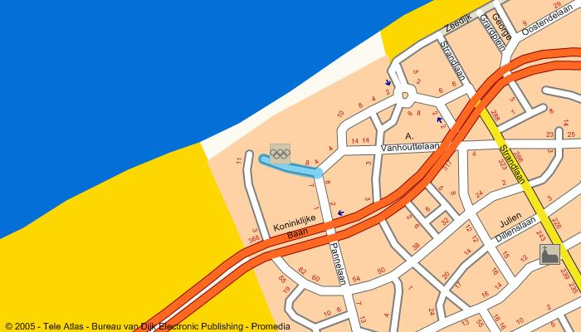
8. The courses.
The Championship will use windward / leeward courses with a gate.
The long distance races will be programmed on day 2 according with the prevailing weather.
9. Penalty system.
Rules RRS 44.1 and 44.2 are changed so that the Two-Turn penalty is replaced by a One-Turn penalty including one tack and one gybe.
10. Scoring.
- 3 races are required to be completed to constitute the Championship.
- The Low Point scoring system of RRS Appendix A will apply.
- The SCHRS will apply.
- When fewer than 4 races are completed, a boat’s score will be the total of her race scores.
- When 4 races or more are completed, a boat’s score will be the total of her race scores excluding her worst score.
11. Radio communications.
- Except in an emergency, a boat shall neither make radio transmissions while racing nor receive radio communications not available to all boats. This restriction also applies to mobile telephones.
12. Prizes.
- Trophies will be awarded to helmsman and crew of the Top 3 finishing boats (F16 & F18).
- Several prizes will be awarded at the discretion of the race organisation.
- PRIZES WILL BE REWARDED ONLY TO TEAMS WHO ATTEND THE PRIZE GIVING (REPRESENTED BY THEMSELVES).
13. Disclaimer of liability.
- Competitors participate in the regatta entirely at their own risk. Attention is drawn to the Fundamental RRS 4, Decision to race. The Organising Authority and the sponsors and their officers, jointly and severally, will not accept any liability for personal or material damage, injury or death sustained in conjunction with or prior to, during, or after the regatta.

14. Insurance.
- Each participant shall have a current Public Liability and Third Party Property Insurance policy, including coverage when racing at the venue of the Championship, of not less than 2.500.000 € or equivalent for each boat per incident.
15. Safety Rules.
- RRS 40 applies at all times while afloat, although flag "Y" will not be displayed.
- Complementary all boats must be equipped with:
A righting rope of 4 meters long and 10 mm in diameter
2 personal flotation devices in accordance with EC specifications
A wet suit or dry suit are obligatory at all times while afloat
Competitors must have a mobile phone on board, this must be used in case of emergency.
Note: lengths and diameters specified in this article have to be read as minimum.
15. Social arrangements.
- Hotels, camping's, youth hotels and apartments can be found on http://www.koksijde.be
- Dienst Voor Toerisme Koksijde-Oostduinkerke
GEMEENTEHUIS, LEOPOLD II LAAN 2
B-8670 Koksijde-Oostduinkerke
Phone: +32 (0) 58 53 21 21
Fax: +32 (0) 58 53 21 22 Weekends: Tel/Fax +32 (0)58 51 29 10
E-mail: toerisme@koksijde.be Website: http://www.koksijde .be
- Bar: Tel +32 (0)58.51.35.71 - GSM Dédé +32 (0)477.58.84.44 or mail clubhouse@kyc.be

WELCOME @ KYC

ENTRY FORM Koksijde Yachting Club October 1-2 2016
Please use BLOCKLETTERS
BOAT
National letters and sail number | …………………………………………………… | Brand of boat: | ……………………………………………………
HELMSMAN | NATIONALITY: .....................
First Name: | …………………………………………………… | Birth date: | ……./……./…………….
Last Name: | …………………………………………………… |  | Male / Female
Address: | ………………………………………………… | Sailing Club: | ……………………………………………………
Zip code: | ……………………………………………………
City: | …………………………………………………… | Telephone: | …………………………………………………..
Country: | …………………………………………………… | GSM: | ……………………………………………………
E-mail | ………………… @ ………………… | Fax: | ……………………………………………………
CREW | NATIONALITY: .....................
First Name: | …………………………………………………… | Birth date: | ……./……./…………….
Last Name: | …………………………………………………… |  | Male / Female
Address: | …………………………………………………… | Sailing Club: | ……………………………………………………
Zip code: | ……………………………………………………
City: | …………………………………………………… | Telephone: | …………………………………………………..
Country: | …………………………………………………… | GSM: | ……………………………………………………
E-mail | …………………… @ …………………… | Fax: | ……………………………………………………
Competitors participate in the regatta entirely at their own risk. Attention is drawn to the Fundamental RRS 4, Decision to race. The Organising Authority will not accept any liability for personal or material damage, injury or death sustained in conjunction with or prior to, during or after the regatta. My crew is aware of these undertakings.
I agree to be bound by the ISAF Rules and by all other rules that govern this event.
Place: …………………….. Date: …….../…………/………………….
……………………………….. ………………………………..
Signature Parents or guardians signature for competitors under the age of 18
FOR ORGANISATION PURPOSE ONLY
LICENCE | ADVERTISING | CLASS ASSOCIATION | MEASUREMENT CERTIFICATE | INSURANCE | WEIGHT |  | T. WEIGHT
YES - NO | YES - NO | YES - NO | YES - NO | YES - NO

